**Easy Guacamole Ingredients**

These are the ingredients you’ll need to make restaurant-worthy guacamole at home:

* **Avocados**: This easy guacamole recipe starts with two peeled and pitted avocados.
* **Onions** and **tomatoes**: Chopped onions and tomatoes add flavor, color, and texture.
* **Seasonings**: This flavorful guacamole is seasoned with fresh garlic, salt, and pepper.
* **Lime juice**: Fresh lime juice lends flavor and keeps the guacamole from browning.

**How to Make Easy Guacamole**

Mash the avocado, stir in the remaining ingredients, and chill in the fridge. That’s it! You’ll find the full, step-by-step recipe below.

**What to Serve With Easy Guacamole**

Serve this easy guacamole with tortilla chips, crackers, or fresh vegetables for dipping. You can also spread it on toast, use it as a hamburger or sandwich topping, or dollop it onto a baked potato. Of course, this guac pairs well with everything in our collection of [Our 21 Best Authentic Mexican Recipes](https://www.allrecipes.com/gallery/best-authentic-mexican-recipes/). The options are endless!

**How to Store and Freeze Easy Guacamole**

Place the guacamole in an airtight container, then cover the top with a thin layer of water, lemon juice, or lime juice (the barrier will keep air from getting in, preventing browning). Store in the refrigerator for up to two days.

**Allrecipes Community Tips and Praise**

“This recipe is so easy to put together and it is delicious,” raves [Sharon Madden](https://www.allrecipes.com/cook/12312074). “My husband really liked it too. We had this as a side with our tacos on taco night and there was nothing left when we were done.”

“This was excellent,” according to [sport1girl](https://www.allrecipes.com/cook/14390686). “I used all the lime juice listed in the recipe and thought it enhanced it but wasn't overpowering. I had a bunch of fresh cilantro and threw that in.”

“I have made this more than once,” says [Jacquelyn](https://www.allrecipes.com/cook/4885977). “Sometimes I add a little hot sauce to it, but most of the time I just like it the way it's written. I often use it as a "spread" for sandwiches. Very fresh, and yummy!”

Editorial contributions by [**Corey Williams**](https://www.allrecipes.com/author/corey-williams/)

Cook Mode (Keep screen awake)

**Ingredients**

1/2X

1X

2X

Original recipe (1X) yields 16 servings

* 4 ripe avocados, peeled and pitted
* 2 small onion, finely chopped
* 2 ripe tomato, chopped
* 2 clove garlic, minced
* 2 lime, juiced
* salt and pepper to taste

**Local Offers**

Oops! We cannot find any ingredients on sale near you. Do we have the correct zip code?

**Directions**

1. Gather all ingredients.

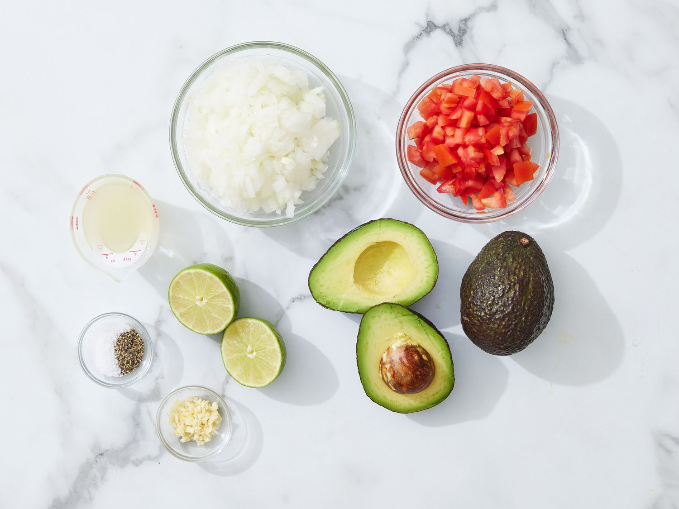

Dotdash Meredith Food Studios

1. Mash avocado in a medium serving bowl.

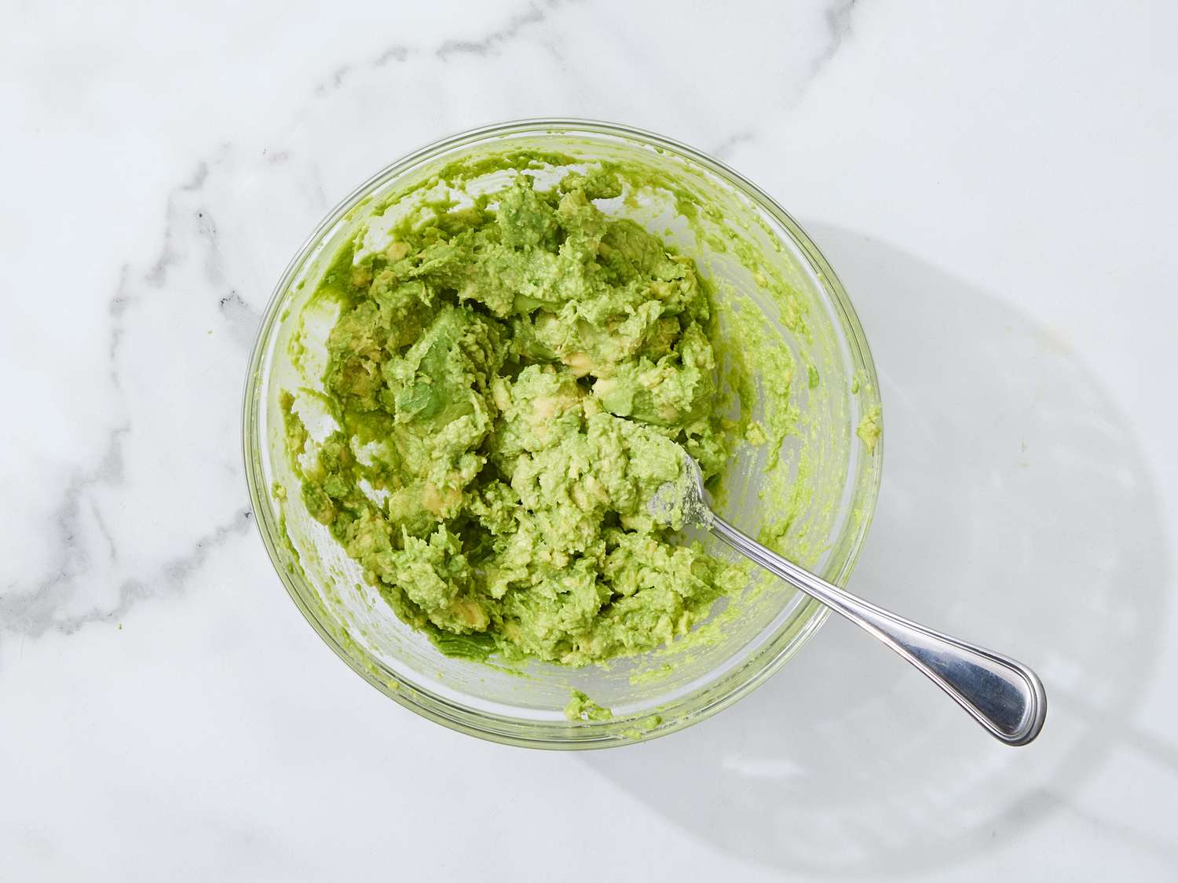

Dotdash Meredith Food Studios

1. Stir in onion, tomato, and garlic.

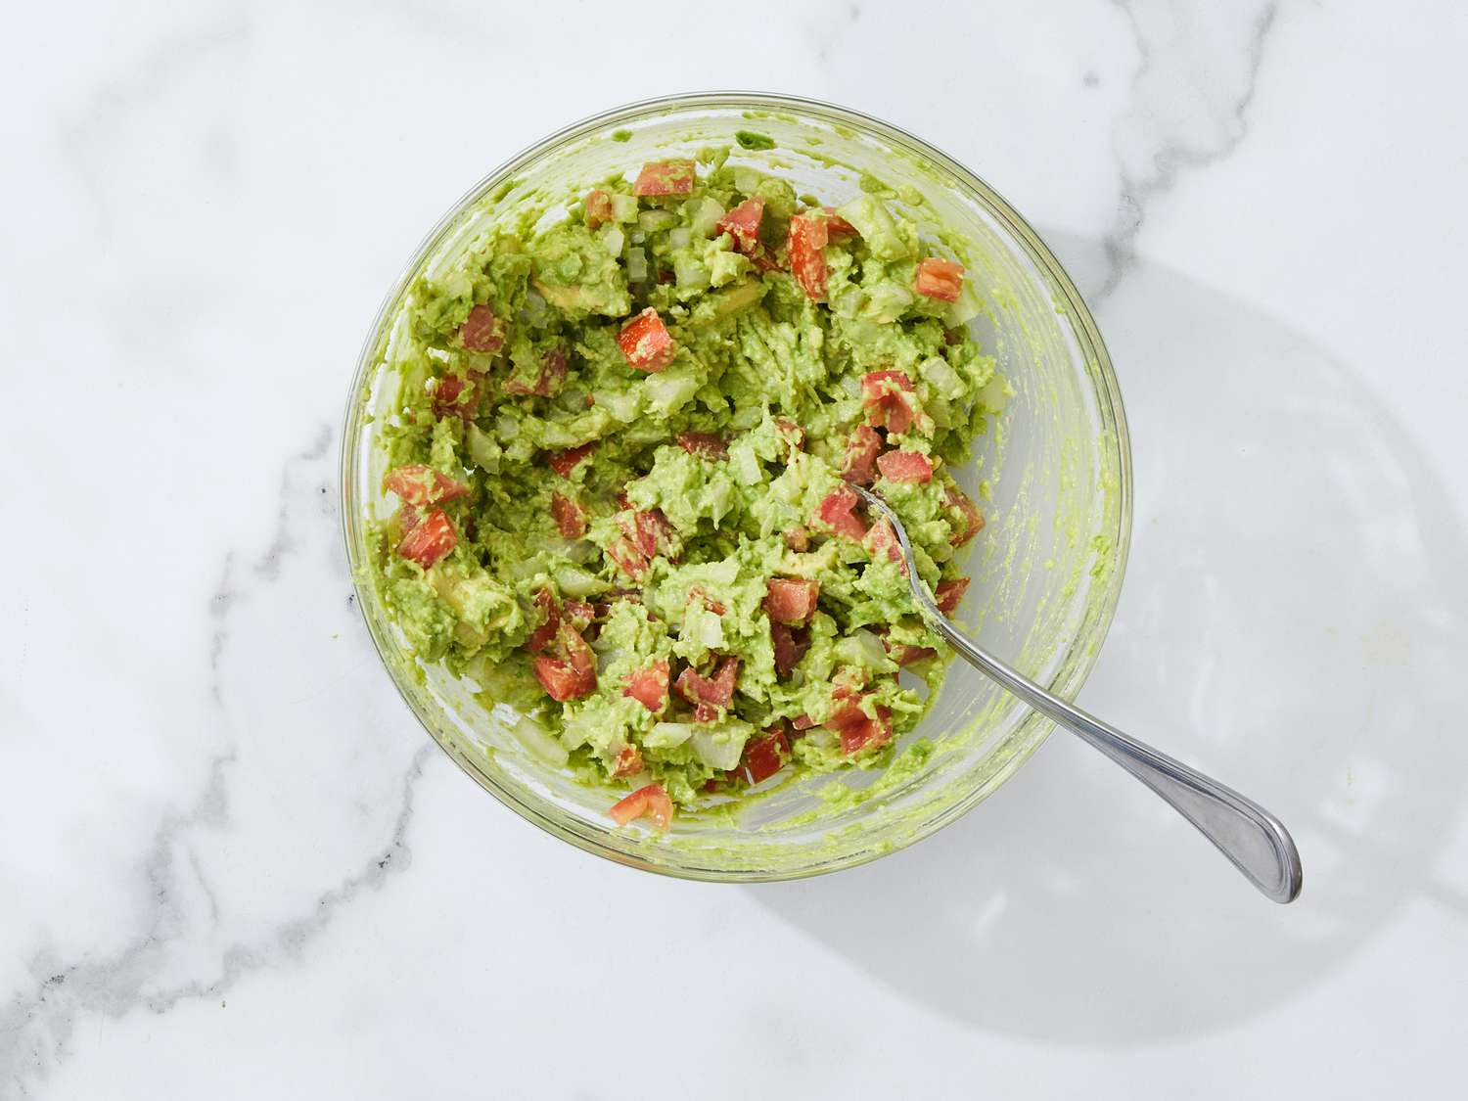

Dotdash Meredith Food Studios

1. Season with lime juice and salt and pepper to taste.

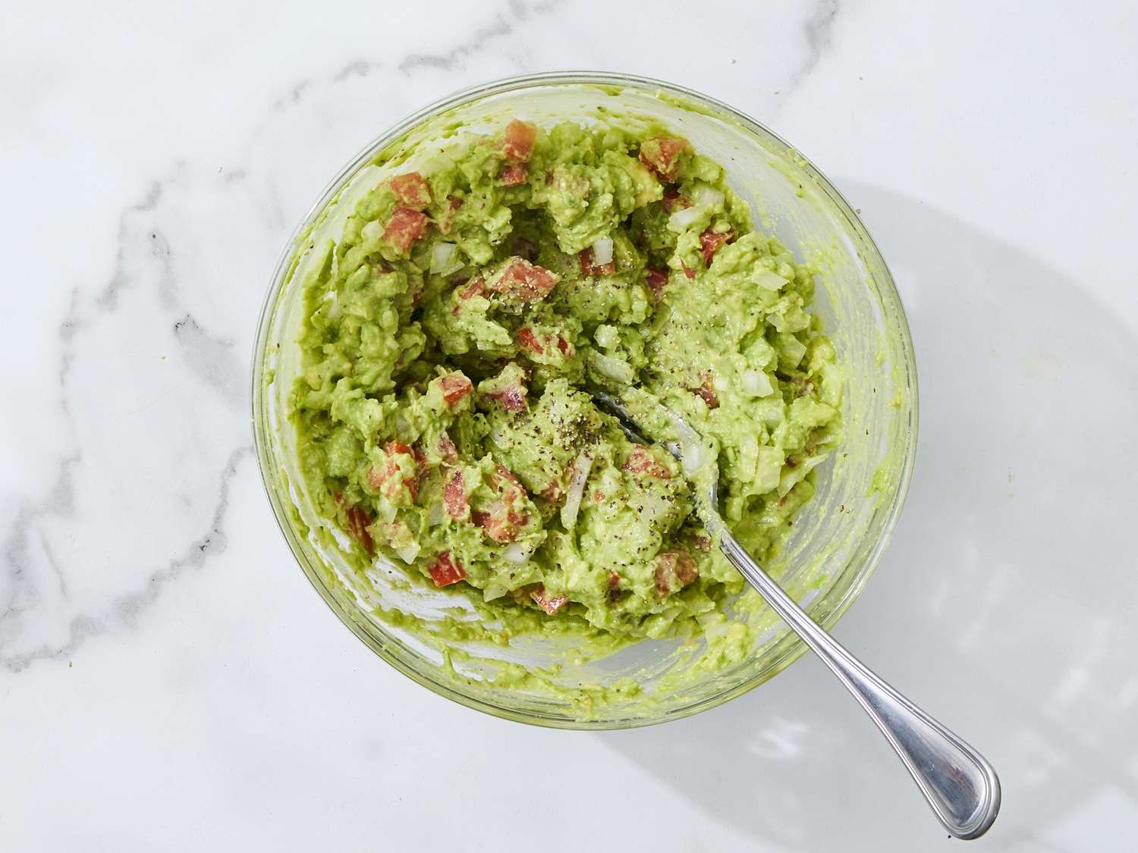

Dotdash Meredith Food Studios

1. Cover and chill guacamole for 30 minutes to allow flavors to blend.

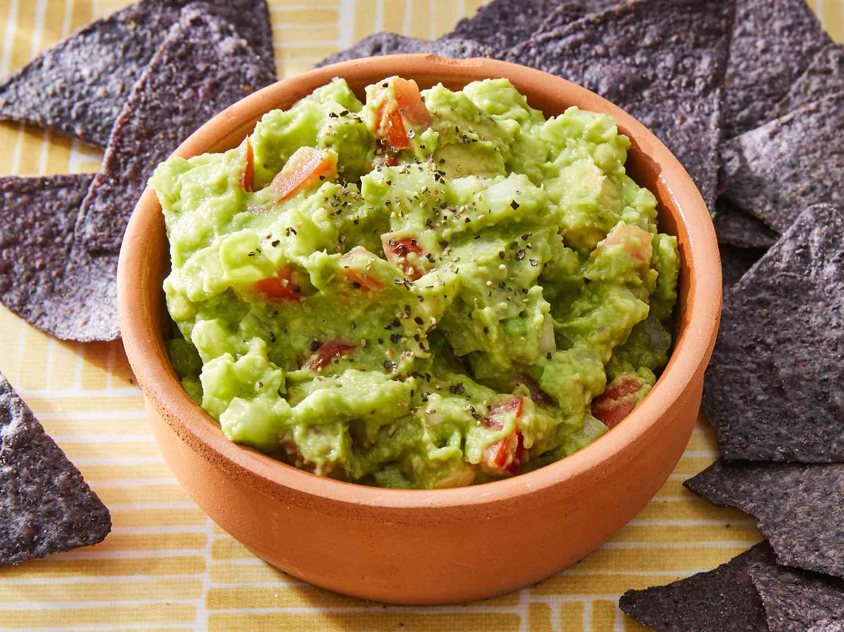

Dotdash Meredith Food Studios